Omar Ahmad

EE 180DA

Lab 1A

Week 7 report

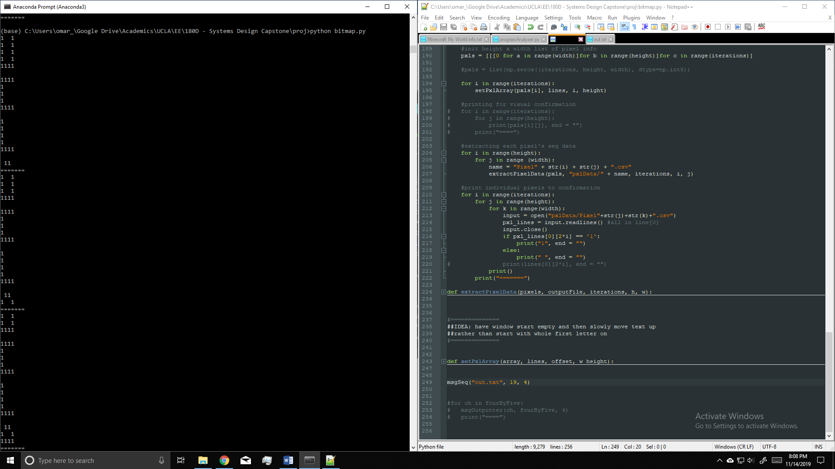This I planned “to further develop this algorithm and at the very least program the entire 3x5 character set. If possible, I would like to implement complete functionality of the 3x5 case so that the rest of the work would simply be manually entering char bitmaps for different potential formats”

I did implement basic functionality for the algorithm. It can now take take a message and output the on/off sequence of each pixel. This is functional but the method used to create the scrolling function could use some work. For example, if the message was “UCLA”, the current implementation would start the first frame (depending on the height of a user-specifiable window) with all of the U and part of the C showing. However, I would like it to start with a blank frame and the first row of the U come up and so on until the entire U was shown.

Currently, the 3x5 and 4x5 character sets are programmed and working – still working on the 5x5 and 6x5 sets. Not too sure if need another set of sets with length 6 (3x6, 4x6, etc.)

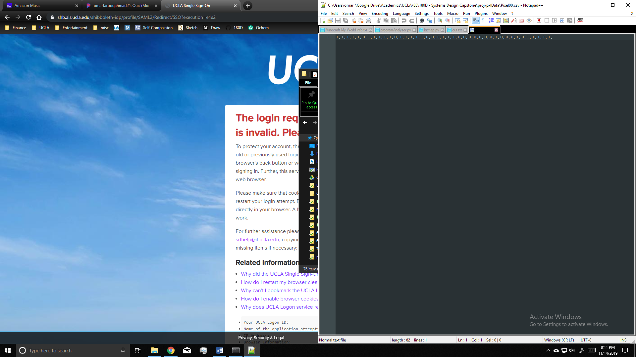The figure on the left shows the terminal ouptut showing the first few frames using the 4x5 character set and the messsage “UCLA 2020!” with window size 4x19. This example produced 76 CSV files – one for each pixel. An example CSV file is below:

In the next week, I plan to further develop the program and implement all the character sets we wish to implement. I would also like to change the ‘animation style’ to start and end with complelety black screen and roll the text into the window.